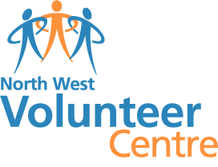
Reasonable Adjustment guidelines and information

- What is Reasonable Adjustment?
Reasonable adjustment in Vocational Education and Training (VET) is the term applied to modifying the learning environment or making changes to the training delivered to assist a learner with a disability or additional need.
- Why make a Reasonable Adjustment?
We make reasonable adjustments in vocational education and training to make sure learners with a disability or additional need have:
- The same learning opportunities as learners without a disability
- The same opportunity to perform and complete assessments as those without a disability
The purpose of reasonable adjustment is to make it possible for learners to participate fully. It is not to give learners with a disability or additional need an advantage over others, to change course standards or outcomes or to guarantee success.
The North West Volunteer Centre take a learner centred approach in the delivery of training. We focus on individual learners and their needs and any decisions about reasonable adjustment will be made collaboratively.
- Preparing and planning for Reasonable adjustment

- Sharing accessible information freely means that both the learner and the trainer can make the best decisions about the course and any reasonable adjustments that might need to be made.
- The NWVC will send course information in advance of training to include
  - Learner information
  - Unit specification with assessment methods
  - Reasonable adjustment information
Please get in touch if you would like to discuss your needs confidentially with one of our trainers
3
Trainer discusses the impact of disability / additional need on learning and support needs directly with the learner to agree best accommodation
1
Learner requests that a reasonable adjustment be made

2
North West Volunteer Centre Trainer asks for evidence of disability e.g. school medical report

