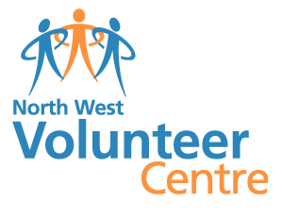
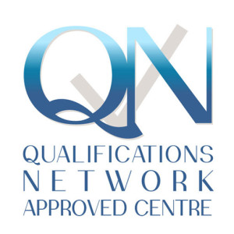
North West Volunteer Centre
Accredited Training Fees list
Group of 12 learners booked together = £500.00 and £40 for each additional learner
Group booking fee includes:
- Learner registration
- Assessment(s)
- Assessment materials
- Certification
- Course Manual
- Use of equipment if applicable i.e. Manikins, AED’s etc

Individual Undertaking a QNUK qualification through NWVC = £42.50 per person
Individual Fee includes:
- Learner registration
- Assessment(s)
- Assessment materials
- Certification
- Course Manual
- Use of equipment if applicable i.e. Manikins, AED’s etc

Reassessment fee (per learner) within the 4 week period of course = £20 per person

Replacement certificate fee = £10.00

Reassessment fee per person on successful Appeal= Free of charge

If you would like further information about our fees please contact Marirose at the centre on 02871 271017 or email: strabane@volunteeringnorthwest.co.uk

