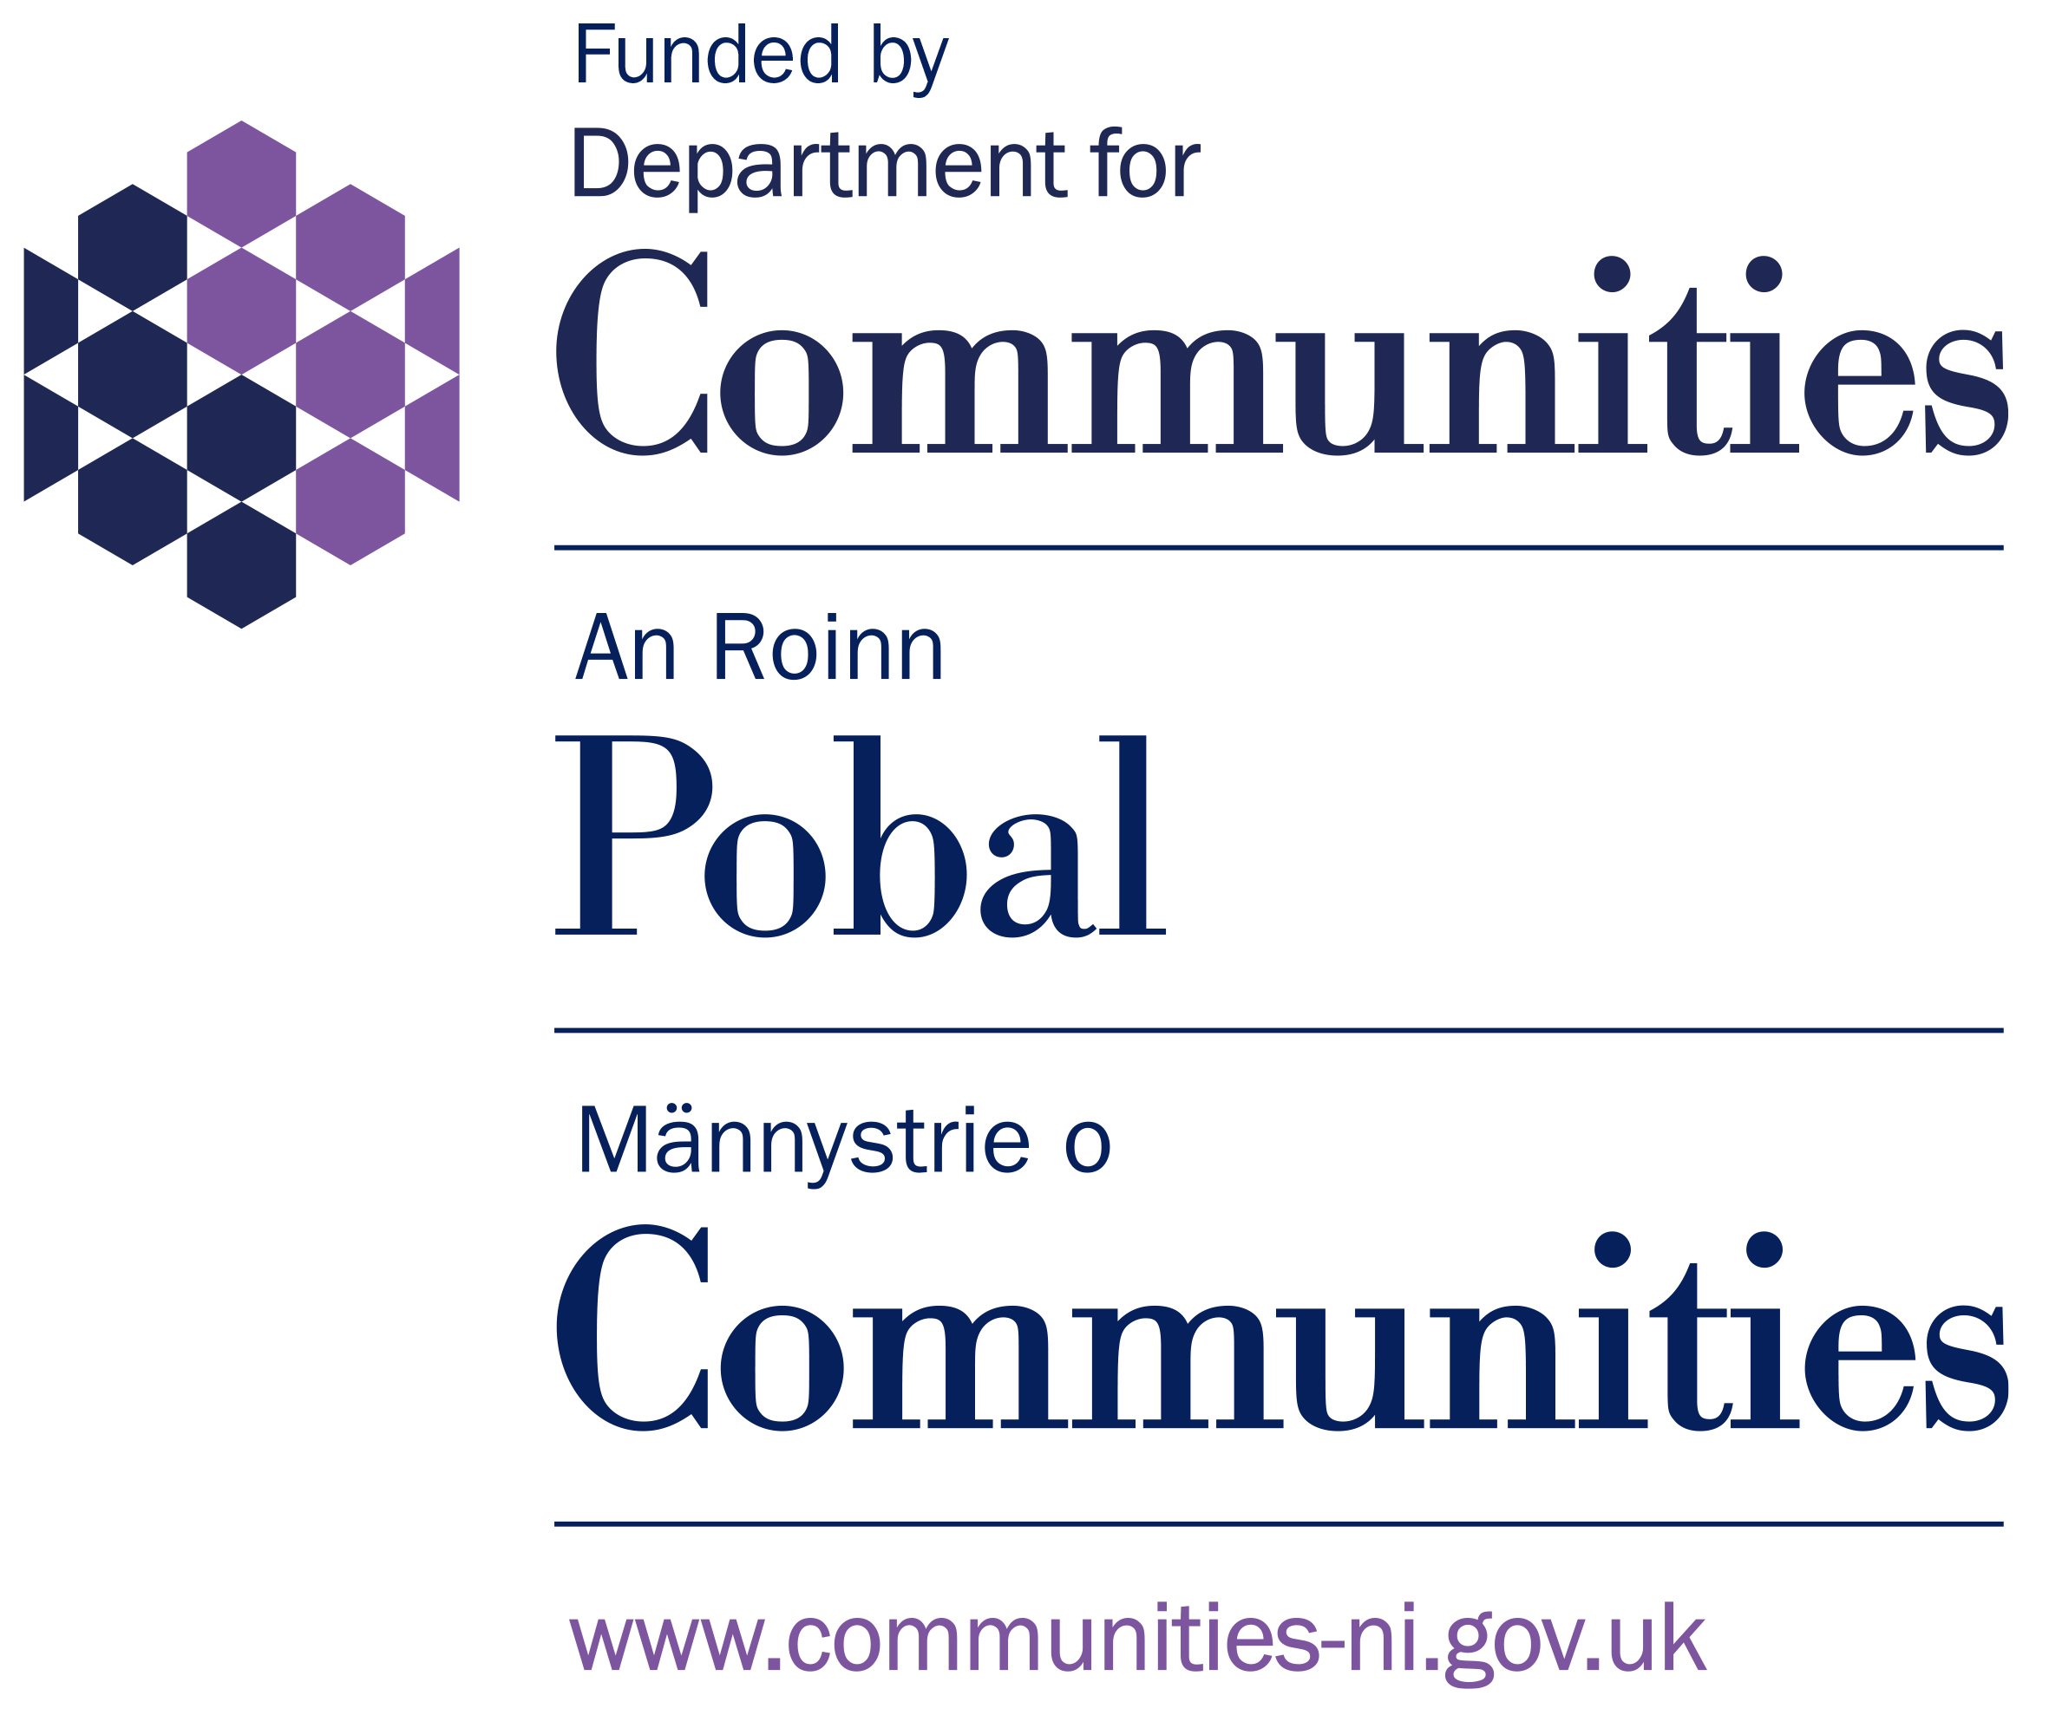
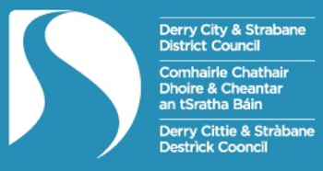
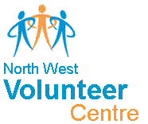

This application is for supporting volunteering in the following rural DEA areas in Derry City and Strabane District Council Area.
Derg Faughan Sperrin
*Please note it is advisable to read the guidance notes before applying*

VOLUNTEERING PROGRAMME
1st Nov 2020 – 31Mar 2021
APPLICATION FORM
This form should be completed by the principal contact person for this application
- Name and address of organisation:

Name of Organisation
Contact Person
Address
Post Code |  |  | Contact number
Email |  |  | Website
Where is your organisation located | Derg | Faughan |  | Sperrin
Social media platforms | Please list the social media you use for your organisation
GDPR Regulations | I give permission for the details on this application to be stored with NWVC and shared with 3rd parties i.e. funder requirements DCSDC / DfC if applicable. Please delete as applicable Yes / No

Do you have a constitution in place? | Yes | No
Are you registered with the NI Charities Commission  If yes please provide your Charity number* | Yes | No
. *Organisations who are not registered with the NI Charities Commission are still eligible to apply

- Please provide a brief list of your organisation’s main activities:

.

- How many volunteers are currently involved in your organisation including committee members?

- In what way are volunteers supporting people in response to Covid-19?

- How as an organisation do you support your volunteers?

- The maximum grant you can apply for is £500. Minimum £250.
Outline below how you will allocate the grant applied for:
Volunteer Expenses
Travel *(38p per mile as per DfC guidelines) | £
Volunteer subsistence | £
PPE (Protective clothing for volunteers) | £
Support for Building Volunteer Capacity
Volunteer training | £
Governance e.g. Access ni disclosures for volunteers | £
Other (please provide details that demonstrates building volunteer capacity) | £
TOTAL GRANT APPLIED FOR | £

- Bank Details.
Account Name:
Bank/Building Society Name:
Bank/Building Society Address:
Sort Code:
Account Number:

- DECLARATION - We confirm that the information in this application is correct and, if successful, we will comply with all requirements of the Volunteering Programme.

Name | Signed
Position | Date

- Checklist - The following documents must be attached to your application
Constitution |  | Last Bank Statement

Return to: Jacqui@volunteeringnorthwest.co.uk or Post to
NWVC, 22 Bishop Street Derry/Londonderry, BT48 6PP
Closing Date Friday 29th January 2021

