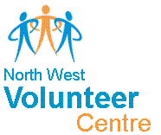
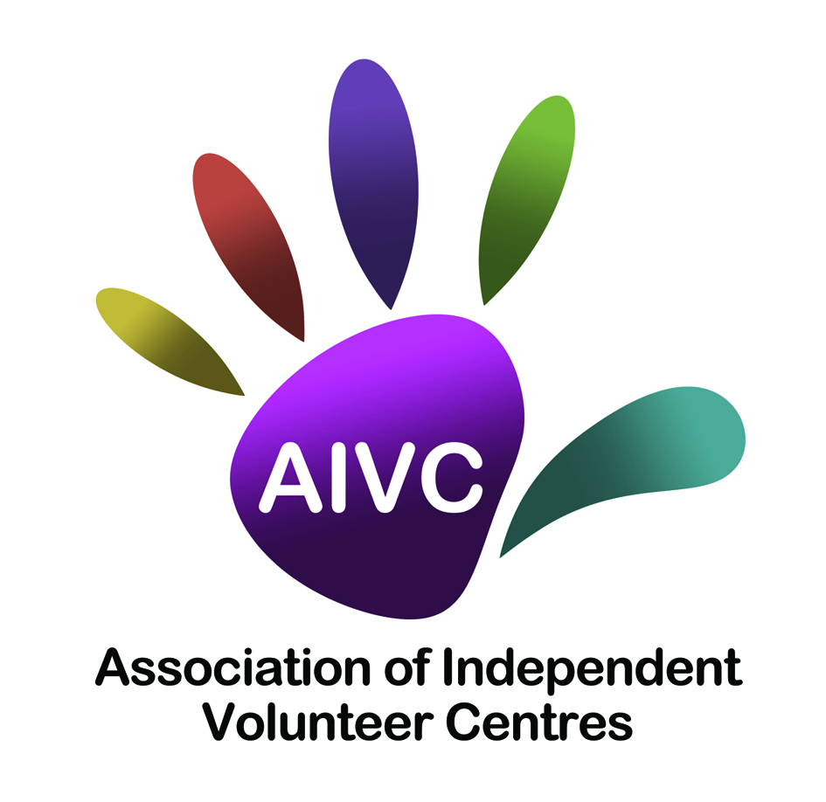

This is an application for funding for a Small Grant to support local volunteer involvement. This is a DfC initiative which is being administered by Limavady Community Development Initiative (LCDI) who have been appointed as an Intermediary Funding Body (IFB). Any grant awarded will be for a maximum of £1,200 and will directly support the key objectives of the DfC Volunteering Strategy and Action Plan.
LCDI are the delivery partner for the following: Association of Independent Volunteer Centres (AIVC), North West Volunteer Centre & Volunteer Now.

Note: This grant is only eligible for expenditure incurred from the date of award until 31 March 2018.

VOLUNTEERING SMALL GRANT APPLICATION FORM
This form should be completed by the principal contact person for this application

- Name and address of organisation:

Contact Person
Name of Organisation
Address
Post Code
Contact Number
Email |  | Website
Council Area
How did you hear about this grant?
What sector does your group fall under?

2 Name of the person with responsibility for volunteers in your group / organisation:

3 If your group is part of a larger organisation, please name this organisation below:

4 What was the annual income of your organisation in the last financial year? (Note if organisations have an annual income of more than £100,000 they are not eligible to apply)

- In order to be eligible, organisations must have an agreed constitution. Do you have a constitution in place?

Yes No but will complete by date

- Please list your organisation’s main activities:

7. Bank Details.

Account Name:
Bank/Building Society Name:
Bank/Building Society Address:
Sort Code:
Account Number:

8 How many volunteers are currently involved with your organisation?

Management committee |  | Others

9 How many of these are:

Not in paid work |  | Young people (16-25)
People with disabilities |  | Older people (50+)
ethnic minorities

10 How many new volunteers do you expect to recruit?

11 How many new volunteers do you expect to be:

Not in paid work |  | Young people (16-25)
People with disabilities |  | Older people (50+)
ethnic minorities

12 Do you have any paid staff? If so how many:

Objective 1 – Please see notes

- What will you do specifically to attract people from the under-represented groups you listed?

Objective 2 – please see notes

14. Please quantify how you will use innovative methods for the recruitment of volunteers, such as social media, website, radio advertisements etc?

Objective 3 – Please see notes

15. Please describe what new approaches you will use to meaningfully engage and support new and existing volunteers?

Objective 4 – Please see notes

- How will you use the grant to benefit the community?

17. How many hours will the volunteers contribute each month?

18. Who are the key beneficiaries of the activities funded by your grant?

19. The maximum grant you can apply for is £1,200. Outline below how you will allocate the grant applied for:

Volunteer Expenses:
Volunteer Recognition Event / Thank You Event (Subsistence) | £
Travel | £
PPE (Protective Clothing) | £
Training: (This must be directly related to volunteering)
Details of training: | £
Project Running Costs:
Heat | £
Light | £
Rent | £
Insurance | £
TOTAL GRANT APPLIED FOR | £

20. Have you applied to any other funder for the same activity/product?
If so please give details below.

DECLARATION
We confirm that the information in this application is correct and, if successful, we will comply with all requirements of the Volunteering Small Grants Programme.

CHECKLIST The following documents must be attached to your application
Constitution |  | Accounts/income expenditure
Last Bank Statement |  | Volunteer Policy

SIGNATURES
Name | Signed | Name | Signed
Position | Date | Position | Date

Return to: smallgrants@lcdi.co.uk

OR

LCDI Small Grants
24d Benevenagh Drive
Limavady
BT49 0AQ

Closing date 12noon Thursday 18th January

